Data Analytics and Artificial Intelligence
Vol: 3(6), 2023
REST Publisher; ISBN: 978-81-948459-4-2
Website: http://restpublisher.com/book-series/daai/

Smart Farming Techniques and Forecasting
(SFTAF)
* S. Perumal Sankar, Eldho Paulose, T.R Santhosh, Ashwin Sibi
Institute of science and Technology, Kerala, India
*Corresponding Author Email: spsankar2004@gmail.com

Abstract: Agriculture plays a crucial role in global food production and is highly dependent on soil quality and weather conditions. This project aims to develop an automated system that assists farmers in optimizing their farming techniques and forecasting weather conditions to improve crop yields. The first step involves analyzing soil nutrients to identify the most suitable fertilizers for a given soil type, taking into consideration the specific crops being grown. Various sensors are used to collect data on soil nutrient levels, and an algorithm is developed to issue warnings for nutrient deficiencies in the soil. The next aspect of the project involves forecasting weather conditions over the next six months using weather forecasting tools and APIs. The live weather data is integrated into the system, providing real-time information on rainfall, temperature, and other relevant weather parameters. The system uses this data to predict potential impacts of excess rainfall on agriculture and issues warnings to farmers, enabling them to take appropriate measures to mitigate the negative effects. The system also incorporates machine learning techniques to continuously improve the accuracy of weather forecasts and fertilizer recommendations based on historical data. This information is made available to farmers and policymakers, helping them make informed decisions to support the resilience of agriculture in their region. The proposed system has the potential to greatly benefit farmers by optimizing their crop yields, reducing crop losses due to nutrient deficiencies and adverse weather conditions, and improving overall farming practices. It also has implications for policymakers in developing effective strategies to support agriculture in the face of changing weather patterns. The project aims to contribute to the sustainable development of agriculture and enhance the resilience of farming operations, ultimately benefiting the agricultural community and global food security.
Keywords: Embedded system, GPS tracking, Monitoring of vessel, weather detection, border alerts, communication system to the vessel, clustering
- INTRODUCTION
Excess rainfall can pose significant challenges to agriculture and food production, resulting in soil erosion, flooding, and increased pest and disease pressure. These issues can lead to reduced crop yields and negatively impact farmers' livelihoods. To mitigate the adverse effects of excess rainfall on agriculture, it is crucial to implement appropriate fertilization and farming practices that are resilient to such conditions. In this context, the proposed project aims to develop an automated system for farmers to improve their farming techniques and forecasting capabilities. The system will utilize data collected from various sensors to issue warnings and improve the yielding efficiency of different crops by identifying nutrient deficiencies in the soil. Additionally, live weather data, including rainfall predictions, will be integrated into the system using APIs to provide real-time information to farmers. The project will focus on tailoring solutions to specific crop types and soil conditions, taking into consideration the unique challenges faced by farmers in different regions. By leveraging advanced technologies such as machine learning and sensor-based data collection, the system aims to provide timely and accurate recommendations to farmers, enabling them to optimize their farming practices and mitigate the impacts of excess rainfall. The ultimate goal of the project is to contribute to the resilience of agriculture in the face of changing weather patterns, by empowering farmers with a robust automated system that combines fertilization and weather forecasting capabilities. By improving crop yields, reducing losses due to nutrient deficiencies and adverse weather conditions, and promoting sustainable farming practices, the proposed system has the potential to benefit farmers, policymakers, and global food security alike.

LITERATURE REVIEW
RISHI GUPTA, et al .suggested a system titled as “Design of a WB-CPI: Weather Based Crop Prediction in India Using Big Data Analytics”.This paper aims at collecting and analyzing temperature, rainfall, soil, seed, crop production, humidity and wind speed data (in a few regions), which will help the farmers improve the produce of their crops. Firstly, we pre-process the data in a Python environment and then apply the MapReduce framework, which further analyses and processes the large volume of data. Secondly, k-means clustering is employed on results gained from MapReduce and provides a mean result on the data in terms of accuracy. After that, we use bar graphs and scatter plots to study the relationship between the crop, rainfall, temperature, soil and seed type of two regions (Ahmednagar, Maharashtra and, Andaman and Nicobar Islands). Further, a self-designed recommender system has been used to predict the crops and display them on a Graphic User Interface designed in a Flask environment. The system design is scalable and can be used to find the recommended crops of other states in a similar manner in the future.[1] S.R. Jino Ramson, et al .suggested a system titled as “Design of a A Self-Powered, Real-Time, LoRaWAN IoT-based Soil Health Monitoring System”.Typical soil health assessment requires intensive field sampling and laboratory analysis. Although this approach yields accurate results, it can be costly and labor intensive and not suitable for continuous tracking of soil properties. Advances in soil sensor and wireless technologies are poised to replace physical sampling and offline measurement with in-field monitoring. This article reports the development, deployment and validation of an Internet of Things (IoT) system for continuous monitoring of soil health.[15] The end nodes of the proposed system, called Soil Health Monitoring Units (SHMUs), are solar powered and can be installed on a field for extended periods of time. Each SHMU transmits soil temperature, moisture, electrical conductivity, carbon dioxide (CO2), and geo-location data wirelessly using LoRaWAN radio technology. Data is received by a LoRaWAN gateway, which uploads it to a server for long-term storage and analysis. Users can view acquired data through a web-based dashboard. The following significant experiments were carried out to validate the developed system:1) a network consisting of eight SHMUs was deployed at an agricultural field site for several weeks and soil health metrics were analyzed using the soil health dashboard; 2) the flexibility of the system was demonstrated by the addition of an extra CO2 sensor allowing an additional variable directly linked to soil health to be recorded; 3) a wireless communication range of 3422 m was estimated at a transmission power of 10 dBm by deploying the developed system on a large field; 4) the average current consumption of a SHMU (including its associated sensors) was estimated to be 13 mA, at this rate, the on-board Li-ion battery is able to sustain a SHMU for several days; 5) a 7 cm × 6.5 cm solar panel was able to fully charge the on-board battery in 14 days while supplying power to the SHMU[9] A GPS-based alarm system that compares the defined and computed value and determines the location of the boat was proposed by N.R Kumar et al. as part of his sailor integral system utilizing elastic cloud compute module. The boundary is also marked as a restricted area. A message alerting the border crossing will be sent if the restricted zone's latitude and longitude match the preset latitude and longitude.[16] Faruk Bin Poyen , et al .suggested a system titled as “Prototype Model Design of Automatic Irrigation Controller”, Irrigation forms one of the primary components of agriculture and food-production. Due to outdated techniques in developing and underdeveloped countries, a huge volume of water is wasted in this process. In this article, we have devised a fuzzy rule-base irrigation controller prototype to put a check on this water wastage by providing an optimal irrigating environment for farming. The prototype Smart Automatic Irrigation Controller (SAIC) has two operational units, viz. Wireless Sensor Unit (WSU) and Wireless Information Processing Unit (WIPU). The purpose of the WSU is to measure weather and soil conditions and calculate the actual water loss due to evapotranspiration. The WIPU processes this calculated value, and perform the necessary control action to regulate the[7] actuators supplying the right amount of water to the farm. An exhaustive rule-base combination model is stacked in the look-up table for decision making. The prototype model is first simulated and then validated in the field for checking the performance efficiency. The simulated results showed capabilities to compensating for water loss by almost 100%. The controller achieved 27% reduction in water usage and a 40% increase in crop yield. The prototype is connected to a cloud-server for data repository and remote access and control. The device is efficient, low cost, and user-friendly so that the end-users can it with ease and comfort. The model is innovative and unique in the sense that it can the irrigation scheduling for all types of crops, across all climatic conditions for all soil types upon feeding the proper soil-crop-growth stage combinations in the inference engine. [10].

PROPOSED SYSTEM
The SFTFS (Smart Farming Techniques and Forecasting System) is a cutting-edge solution designed to revolutionize the monitoring and management of soil data in tapioca and banana plantations. Unlike existing systems, which have limitations, the SFTFS utilizes a comprehensive array of sensors, including NPK sensor, DHT11 sensor, pH sensor, and soil moisture sensor, in conjunction with a powerful microcontroller NodeMCU, to collect and analyze real-time data on critical soil parameters such as nutrition levels, temperature, humidity, pH, and moisture content. This wealth of data allows farmers to make informed decisions about soil management practices, optimize crop growth, and maximize yield. The SFTFS empowers farmers with precise and accurate information, enabling them to implement timely interventions and preventive measures to avoid soil-related issues. With its advanced capabilities, the SFTFS represents a significant advancement in smart farming, bringing unprecedented levels of efficiency, sustainability, and productivity to tapioca and banana plantations.

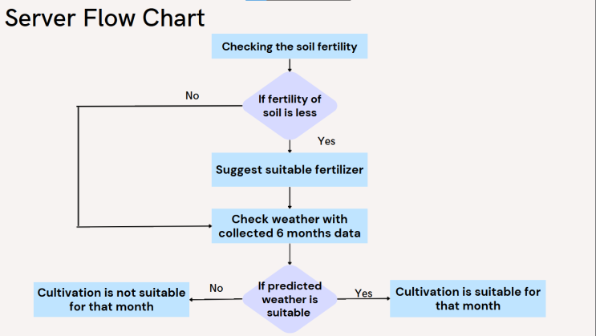

FIGURE 1. Flowchart of the system

The SFTFS has seamlessly integrated a variety of sensors, including NPK sensor, DHT11 sensor, pH sensor, and soil moisture sensor, with the powerful microcontroller Node MCU. These sensors work in tandem to collect crucial real-time data on soil nutritional levels, temperature, humidity, pH, and moisture content in tapioca and banana plantations. The Node MCU serves as a reliable gateway for transmitting the collected sensor data to the server. Leveraging its capabilities as a microcontroller, the Node MCU efficiently collects, processes, and packages the data from the sensors. It then establishes a secure connection with the server, using appropriate protocols, to transmit the data in real-time. This ensures that the data is promptly and accurately delivered to the server for further analysis and processing. The integration of various sensors with the Node MCU enables continuous monitoring of soil conditions and provides invaluable insights for optimizing soil management practices. The seamless data transmission to the server allows for real-time analysis and decision-making, empowering farmers to make informed choices to improve crop health and productivity.
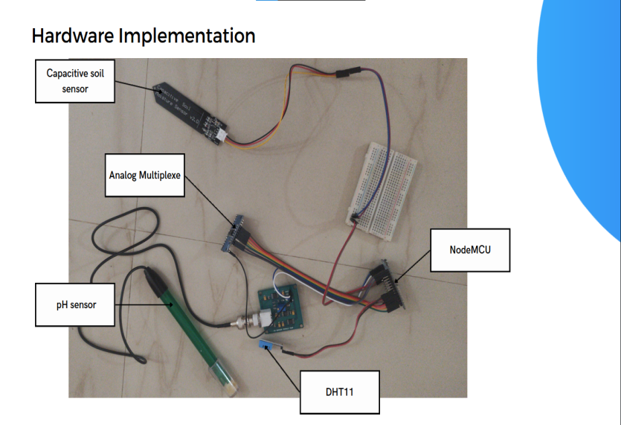
FIGURE 2. Hardware Implementation

The collected sensor data is seamlessly transmitted to a self-built server using FastAPI, a state-of-the-art web framework written in Python, along with the reliable and cost-effective Raspberry Pi single-board computer. This powerful combination allows for efficient data transfer and storage. Once received, the server undertakes robust data processing, validation, and error handling to ensure the integrity and security of the information. The data is carefully analyzed to identify patterns, trends, and potential issues. Any inconsistencies or errors are promptly addressed through the server's comprehensive error handling mechanisms. Additionally, stringent data validation measures are in place to verify the accuracy and reliability of the sensor data. This ensures that the data utilized for decision-making is of the highest quality, empowering farmers to make informed choices about soil management strategies. The use of FastAPI and Raspberry Pi in the SFTFS underscores its commitment to cutting-edge technology, scalability, and data security, making it a powerful and reliable solution for smart farming in tapioca and banana plantations.

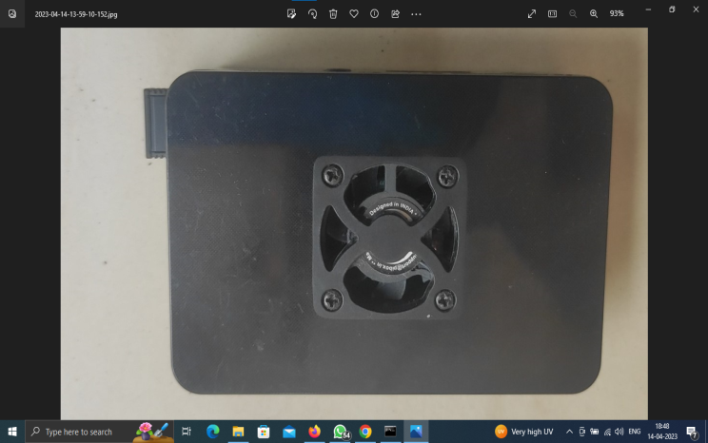

FIGURE 3. Server

RESULTS AND DISCUSSIONS
The processed soil data is presented on a visually appealing website developed using ReactJS, a popular JavaScript library for building user interfaces. The website offers a user-friendly interface that allows farmers to easily view the real-time sensor data. The website prominently displays threshold values for NPK, pH, and soil moisture, which have been predefined based on optimal ranges for tapioca and banana plantations. To aid in quick identification of potential issues, the displayed data is visually enhanced by color-coded indicators. If any of the sensor values fall below or exceed the set thresholds, the corresponding data is highlighted in a different color, signaling the deviation. This enables farmers to promptly identify any anomalies in soil nutrition levels and take necessary actions, such as adjusting fertilizer application or irrigation, to rectify the issue in a timely manner. The use of ReactJS in the website development ensures a responsive and interactive user experience, allowing farmers to easily monitor and interpret the soil data. The threshold-based color-coded display facilitates quick decision-making and proactive soil management, optimizing crop health and yield in tapioca and banana plantations.
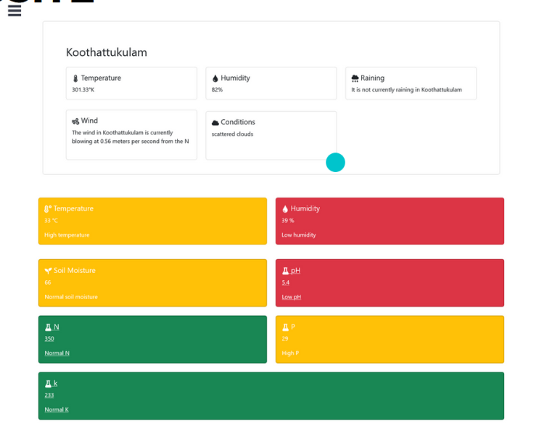
FIGURE 4. Website

If any of these sensor values fall below or exceed the set thresholds, the corresponding data on our website changes color, instantly drawing attention to potential deviations from optimal levels. This visual indication allows users to quickly identify any problems with the soil health and take necessary actions, such as adjusting fertilizer application or irrigation schedules, to rectify the issue promptly. We also provide a seamless routing to our solutions and help web page, where users can find comprehensive information on our innovative smart farming solutions, including soil moisture management. Our solutions are designed to empower farmers with real-time monitoring and management capabilities, enabling them to optimize crop health and productivity.
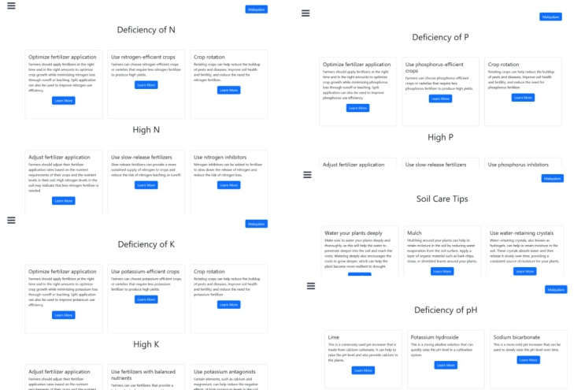

FIGURE 5. Solution In English
To ensure that our website is accessible to local farmers, we have incorporated English and Malayalam language support. This means that all the soil tip cares and fertilizer values on our website can be displayed in both English and Malayalam languages. We understand the importance of communicating information in the language that farmers are most comfortable with. By providing support for both English and Malayalam languages, we aim to make it easier for local farmers to understand and interpret the data presented on our website. Our goal is to ensure that all farmers, regardless of their language preferences, can easily access and utilize the information provided on our website. We are committed to catering to the diverse needs of our users and providing them with a seamless experience, whether they prefer English or Malayalam language.

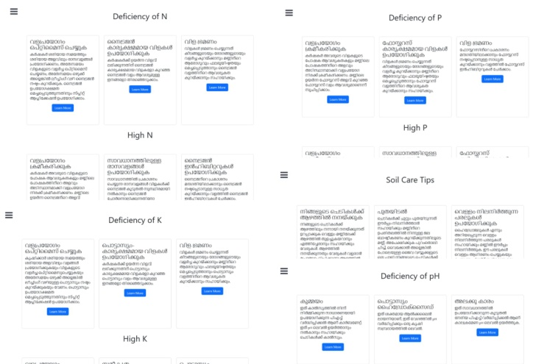
FIGURE 6. Solution in Malayalam

At our website, we understand the importance of weather forecasting in agriculture. In addition to soil data monitoring, we have introduced rain prediction using advanced techniques such as the Long Short-Term Memory (LSTM) algorithm. This algorithm analyzes historical weather data and predicts the probability of rainfall for the next 180 days, providing farmers with valuable insights for planning their agricultural activities.The rain prediction information is displayed on our website, allowing farmers to make informed decisions about irrigation, fertilizer application, and other crop management practices based on the expected rainfall patterns. This helps farmers optimize their farming activities and adapt to changing weather conditions, ultimately improving crop yields and reducing risks associated with weather-related uncertainties.
In the context of our rain prediction model, "loss" refers to a mathematical measure that quantifies the difference between the predicted rainfall probabilities and the actual rainfall observations. It indicates how well the model is performing in predicting the rainfall probabilities. The loss is calculated during the training phase of the LSTM algorithm, where the model is trained on historical weather data. During training, the model tries to minimize the loss by adjusting its parameters to improve the accuracy of its predictions. A lower loss value indicates that the model is able to accurately predict the rainfall probabilities, while a higher loss value indicates that the model's predictions are less accurate.
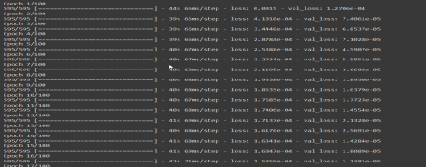
FIGURE 7. Prediction Loss

Furthermore, we have integrated live weather data from an API into our website, providing real-time weather updates to farmers. This allows farmers to stay updated with the latest weather conditions in their region, helping them make timely decisions for their farming operations. We are committed to providing comprehensive and up-to-date weather information to farmers, enabling them to make informed decisions and optimize their farming practices. Our rain prediction and live weather data features are designed to empower farmers with valuable insights for successful crop management.

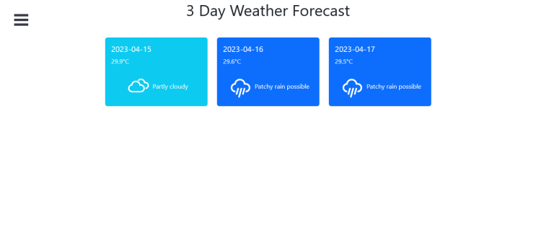
FIGURE 8. Days weather forecast

Saving the collected soil nutrition data as a CSV (Comma-Separated Values) file is a smart decision as it allows for easy storage, retrieval, and analysis of the data. CSV is a simple and widely used file format that can be opened and processed by various statistical and data visualization tools, making it a convenient choice for data analysis in agricultural research and higher studies. By saving the data in a CSV file, researchers and stakeholders can easily export and import the data into different software applications, such as Excel, R, Python, or other statistical packages, for further analysis. This allows for in-depth evaluation and analysis of the soil nutrition data, including calculating statistical measures, generating plots and charts, identifying trends, and conducting advanced data analytics. The data stored in the CSV file can provide valuable insights into soil health, nutritional requirements, and trends over time. It can be used for various purposes, such as conducting research on soil fertility, analyzing the effectiveness of fertilizer application, studying the impact of different agricultural practices on soil nutrition, and identifying patterns or anomalies in soil nutrition data. Furthermore, the CSV file can also serve as a valuable resource for higher studies, such as academic research, thesis projects, or scientific publications. It can be used as a reference for supporting research findings, validating hypotheses, and sharing data with other researchers for collaboration or replication of studies. In summary, saving the collected soil nutrition data as a CSV file provides a convenient and flexible way to store, retrieve, and analyze the data for evaluation and higher studies. It enables researchers and stakeholders to gain valuable insights into soil health, make informed decisions for agricultural practices, and contribute to the advancement of agricultural research and knowledge.

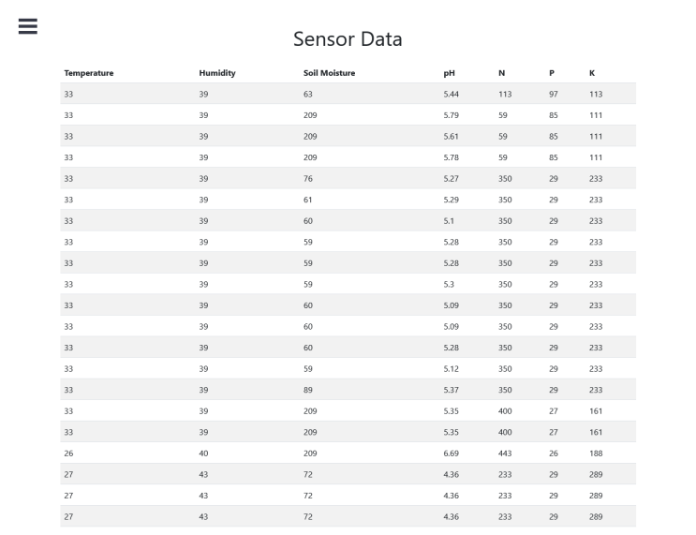
FIGURE 9. Sensor Data

CONCLUSSION

our project has successfully developed a comprehensive soil data monitoring system using various sensors, a microcontroller NodeMCU, FastAPI, ReactJS, and Raspberry Pi. The system enables real-time data collection, processing, and visualization of soil nutrition parameters, temperature, humidity, pH, and moisture content. Threshold values are set and displayed on the website, which changes color to indicate any deviations from the desired levels. The system also supports English and Malayalam language for wider accessibility among local farmers. Furthermore, we have incorporated rain prediction for 180 days using LSTM algorithm and live weather data from an API, providing farmers with crucial information for planning their agricultural activities. The collected soil nutrition data is saved as a CSV file, allowing for further evaluation and higher studies using statistical and data visualization tools, which can offer valuable insights into soil health and trends over time. Overall, our project aims to provide an effective solution for soil data monitoring and analysis, empowering farmers with real-time information to optimize their agricultural practices. The system has potential applications in Tapioca and Banana plantations, and can contribute to the advancement of agricultural research and knowledge. We are proud of our achievements and believe that our project has the potential to make a positive impact in the field of agriculture. We are greatly indebted to our project supervisor Dr.Perumal Sankar and project coordinators Prof. (Dr.). Perumal Sankar and Asst. Prof. Dhanya. R, whose constant support and guidance helped us in the completion of our project.

REFERENCES

- D. Bose. (2020). Big Data Analytics in Agriculture. [Online]. Available:https://www.researchgate.net/publication/339102917
- R. Priya, D. Ramesh, and E. Khosla, ‘‘Crop prediction on the region belts of india: A Naïve Bayes MapReduce precision agricultural model,’’ in Proc. Int. Conf. Adv. Comput., Commun. Informat.
- W. Fan, C. Chong, G. Xiaoling, Y. Hua, and W. Juyun, ‘‘Prediction of crop yield using big data,’’ in Proc. 8th Int. Symp. Comput. Intell. Design (ISCID), Dec. 2015, pp. 255–260, doi: v10.1109/ISCID.2015.191..
- Fancello, Serra, P., Schintu, A., & Zoratti, A. “Performance evaluation of a tracking system for intermodal traffic: an experimentation in the Tyrrhenian area”, 2020, pp. 1–12.
- M. Ramya, C. Balaji, and L. Girish, ‘‘Environment change prediction to adapt climate-smart agriculture using big data,’’ Int. J. Adv. Res. Comput. Eng. Technol., vol. 4, no. 5, pp. 1995–2000,
- A. K. Kushwaha and S. Bhattachrya, ‘‘Crop yield prediction using agro algorithm in Hadoop,’’ Int. J. Comput. Sci. Inf. Technol. Secur., vol. 5, no. 2, pp. 271–274, 2015.
- P. C. Reddy and A. S. D. Babu, ‘‘Survey on weather prediction using big data analystics,’’ in Proc. 2nd IEEE Int. Conf. Electr., Comput. Commun. Technol., Feb. 2017, pp. 1–6.
- P. S. Vijayabaskar, R. Sreemathi, and E. Keertanaa, ‘‘Crop prediction using predictive analytics,’’ in Proc. Int. Conf. Comput. Power, Energy Inf. Commun. (ICCPEIC), Mar. 2017, pp. 370–373.
- S.Rajeswari, R. Scholar, K. Suthendran, and K. Rajakumar, ‘‘A smart agricultural model by integrating IoT, mobile and cloud-based big data analytics,’’ in Proc. Int. Conf. Intell. Comput. Control, 2017, pp. 1–5.
- K. Charvat, K. C. Junior, T. Reznik, V. Lukas, K. Jedlicka, R. Palma, and R. Berzins, ‘‘Advanced visualisation of big data for agriculture as part of databio development,’’ in Proc. IEEE Int. Geosci. Remote Sens. Symp. (IGARSS), Jul. 2018, pp. 415–418.
- P. Shah, D. Hiremath, and S. Chaudhary, ‘‘Towards development of spark based agricultural information system including geo-spatial data,’’ in Proc. IEEE Int. Conf. Big Data (Big Data), Dec.
- M. P. Darji, V. K. Dabhi, and H. B. Prajapati, ‘‘Rainfall forecasting using neural network: A survey,’’ in Proc. Int. Conf. Adv. Comput. Eng. Appl., Mar. 2015, pp. 706–713, doi: 10.1109/ICACEA.2015.7164782.
- V. K. Dabhi and S. Chaudhary, ‘‘Hybrid wavelet-postfix-GP model for rainfall prediction of Anand region of India,’’ Adv. Artif. Intell., vol. 2014, pp. 1–11, Jun. 2014, doi: 10.1155/2014/717803.
- M. Motlhabi, P. Pantsi, and R. Netshiya, ‘‘A machine learning deepdive analysis into network logs,’’ in Proc. ICCWS, 2021, p. 213, doi: 10.34190/IWS.21.019.
- Z. Doshi, S. Nadkarni, R. Agrawal, and N. Shah, ‘‘AgroConsultant: Intelligent crop recommendation system using machine learning algorithms,’’ in Proc. 4th Int. Conf. Comput. Commun. Control Autom. (ICCUBEA), Aug. 2018, pp. 1–6.
- M. Kumar and M. Nagar, ‘‘Big data analytics in agriculture and distribution channel,’’ in Proc. Int. Conf. Comput. Methodol. Commun. (ICCMC), Jul. 2017, pp. 384–387.
- A. Savla, N. Israni, P. Dhawan, A. Mandholia, H. Bhadada, and S. Bhardwaj, ‘‘Survey of classification algorithms for formulating yield prediction accuracy in precision agriculture,’’ in Proc. Int. Conf. Innov. Inf., Embedded Commun. Syst. (ICIIECS), Mar. 2015, pp. 1–7.
- Q. Huang, Z. Chen, W. Wu, A. de Wit, F. Teng, and D. Li, ‘‘China crop growth monitoringsystem-methodology and operational activities overview,’’ in Proc. IEEE Int. Geosci. Remote Sens.Symp., Jul. 2011, pp. 2961–2964.
- G. M. Alves and P. E. Cruvinel, ‘‘Big data environment for agricultural soil analysis from CTdigital images,’’ in Proc. IEEE 10th Int. Conf. Semantic Comput. (ICSC), Feb. 2016, pp. 429–431, doi:10.1109/ICSC.2016.80.
- M. R. Bendre, R. C. Thool, and V. R. Thool, ‘‘Big data in precision agriculture: Weather forecasting for future farming,’’ in Proc. 1st Int. Conf. Next Gener. Comput. Technol. (NGCT), Sep.2015, pp. 744–750, doi: 10.1109/NGCT.2015.7375220.
- Zentut. (Accessed: Feb. 28, 2021). Data Mining Techniques. Zentut.com. [Online]. Available:https://www.zentut.com/data-mining/datamining-techniques/
- M. A. Beyer and D. Laney, ‘‘The importance of ‘big data’: A definition,’’ Gartner, Stamford, CT, USA, Tech. Rep. 1644565, 2012.
- X. E. Wang and W. L. Decker, ‘‘The use of distance coefficient in the research on agro climatological resemblance,’’ J. Nanjing Inst. Meteorol., vol. 12, no. 2, pp. 187–199, 1989.
- Kaggle. (Accessed: Mar. 5, 2021). Datasets. Kaggle.com. [Online]. Available: https://www.kaggle.com/datasets
- The University of Dayton. (Accessed: Mar. 8, 2021). Average Daily Temperature Archive. Udayton.edu. [Online]. Available: https://academic. udayton.edu/kissock/http/Weather/
- Tutorials Point. (Accessed: Apr. 2, 2021). Hadoop—MapReduce. Tutorialspoint.com. [Online]. Available: https://www.tutorialspoint. com/hadoop/hadoop_mapreduce.htm
- S. Chaudhary. (Accessed: Mar. 20, 2021). Why 1.5’ in IQR Method of Outlier Detection?Towardsdatascience.com. [Online]. Available:https://towardsdatascience.com/why-1-5-in-iqr-

